7/16/2026
Abulele Ntwanambi
[company name]

Name : Abulele
Surname: Ntwanambi
218276400
Project 3 Individual project

Introduction
Our team has been given a task to build a student market place for the CPUT community. I have been given the task to build the order entity of the system. Provided below are the ERD diagrams for the overall system and the separate entity assigned to me. To visually illustrate the structure , layout and functionality of the order entity I have included the wireframes in the documentation as well.
System ERD
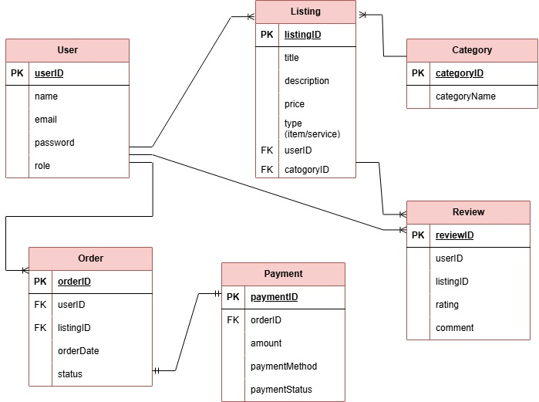

Order entity ERD
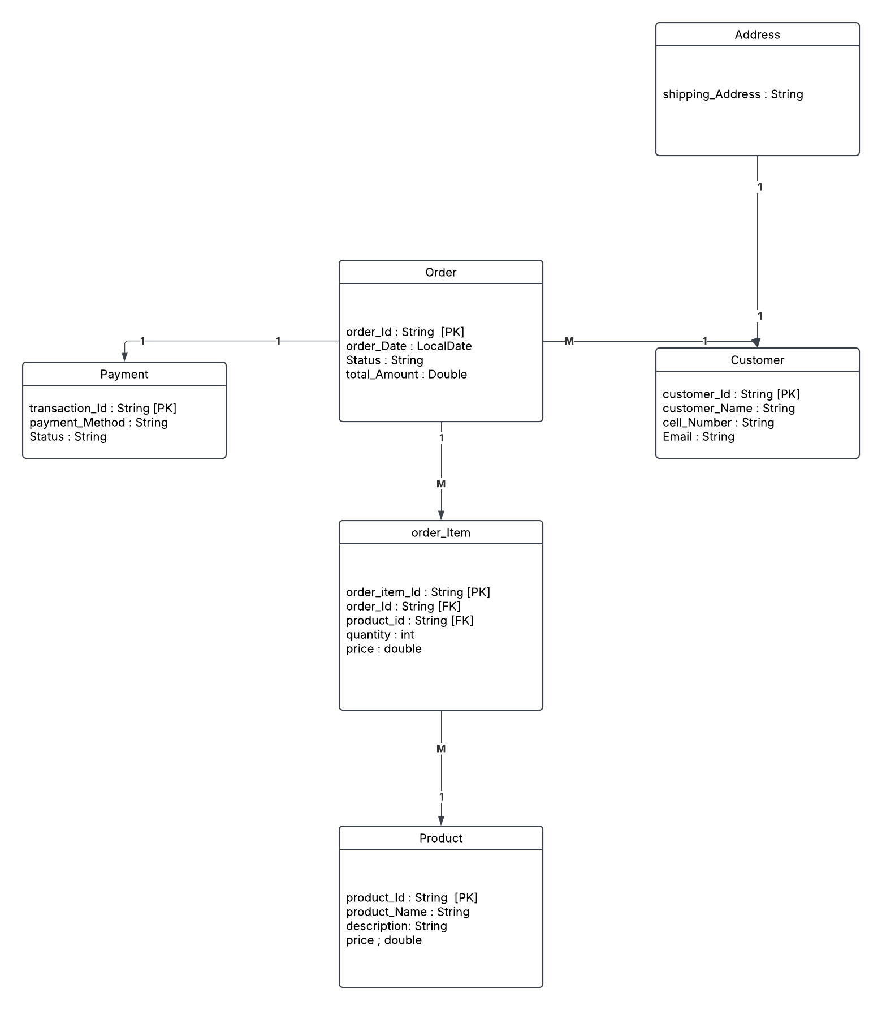

Business Rules
Customer
BR01 : A customer must register with a valid email and cell phone number to create ab account before they can place an order.
Address
BR02 : A customer must have a valid shipping address to deliver an order.
Order
BR03: An order must contain at least one item and must belong to an existing customer.
OrderItem
BR04 : The order item quantity must be greater than zero.
Product
BR05 : A product must have a name, a description and the price cannot be negative.
Payment
BR06 : The payment can only be processed for an existing order. Customer must select a valid payment method.
Order entity Wireframe(s) uploaded in prototype mode

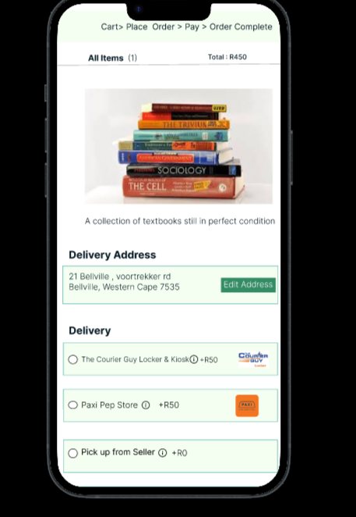
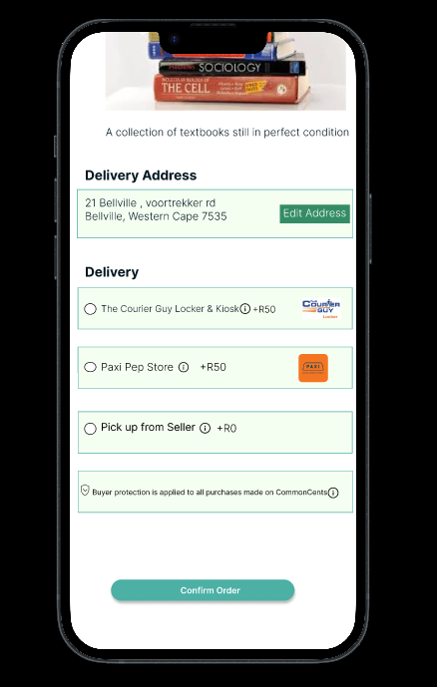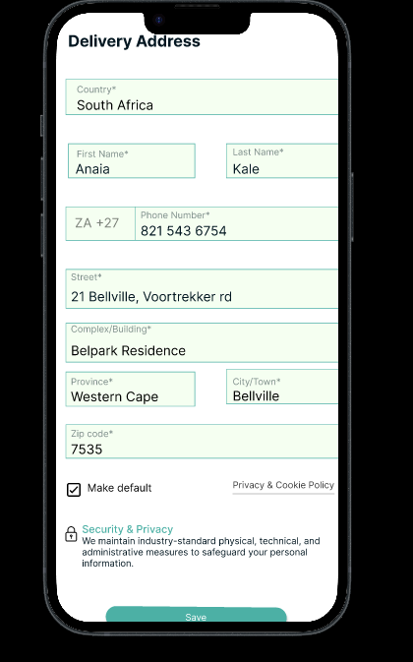
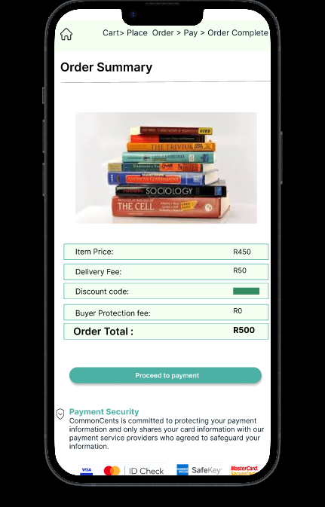
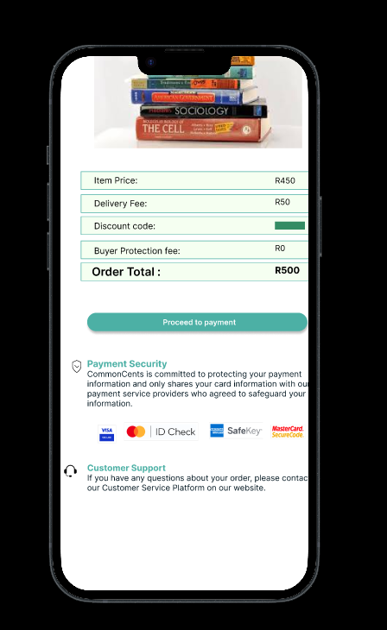

Reflection Report
Reflection on teamwork
My role in the group is a project manager and scrum master. I organize meetings and do follow up on the teams progress. Our task for the second term was to discuss and design the structure of the application. Choose the visual design and layouts, the colors etc.
This task was done collaboratively as a group which was beautiful because were able to share idas freely and come to consensus . I as the project manager ensured every member participated by giving individual tasks such as challenging everyone comes with an idea in each and every meeting .
Reflection on individual work/ progress
For this second deliverable we were tasked to design the structure and layout of the application and assign entities each individual works on. Thereafter we had to design an erd and wireframes for the assigned entity. We also had to decide on the name of the application which is called the CommonCents.
I chose the order entity which is also a cart entity. It works by compiling the customer’s items and processing them for check out. I created the erd and ensured to show all relationships and label the entities clearly and state each entity’s attributes as well as the primary keys and foreign keys. I created the erds using Lucid application this was not challenging for me as I had experience of working with erds from one of our second year modules and projects.
I created the wireframes using an application/ software called figma where I designed the layout of the order entity. Applying previous knowledge acquired from previous years of study was very beneficial for completing this deliverable . I had learned about figma from a bootcamp course I completed and I was also taught about wireframe designs in one of the modules of second year as well.
Overall this second deliverable for me was very interesting and fun to complete as it basically felt like a task of applying all that I have learned through out the years to test my skills and my capacity of retaining knowledge so I was thrilled when completing the project .
What I have learned
In this project I have learned how to manage a team, this has helped improve my leadership skills. I have also learned to resolve conflicts which requires effective communication but overall I have learned how to share ideas with team members and integrate those ideas and turn them into a problem solving project.

Improvement on Myself
I want to improve working according to sprints and not slacking. I struggle with balance between multiple modules sometimes so I fail to complete my project tasks on time according to the sprints.
Improvement on group
The group has fairly improved in comparison to the first task we had together but going forward perhaps we can all try to find a balance and agreement on meeting schedules. Certain individuals do not show up to meetings at times because of schedule conflicts however we aim to improve greatly in this area.

